Healthcare Data Pipeline Project Screenshots
Screenshot 1: Source Data in Azure Data Lake Storage Gen2
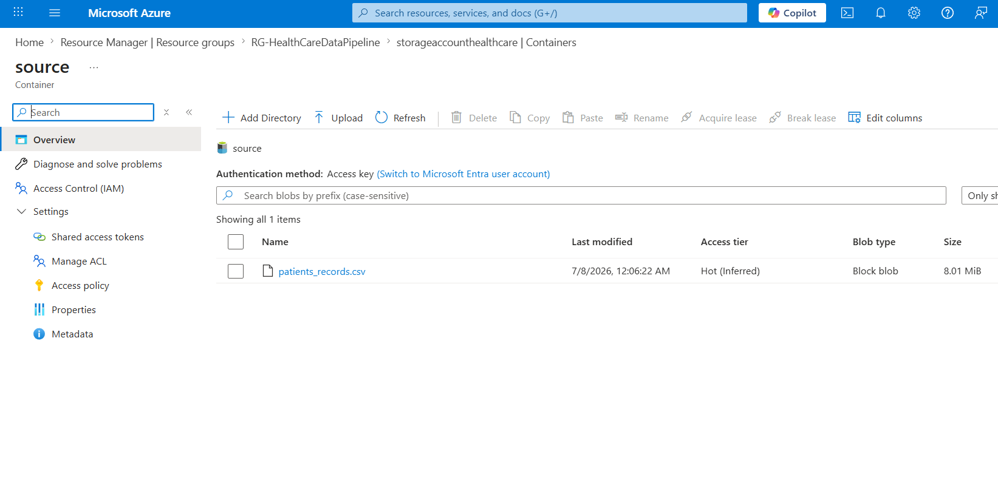
Description:
The healthcare patient dataset is stored in Azure Data Lake Storage Gen2 inside the source container. This serves as the raw data source for the data pipeline before ingestion into Databricks.

Screenshot 2: Bronze Layer
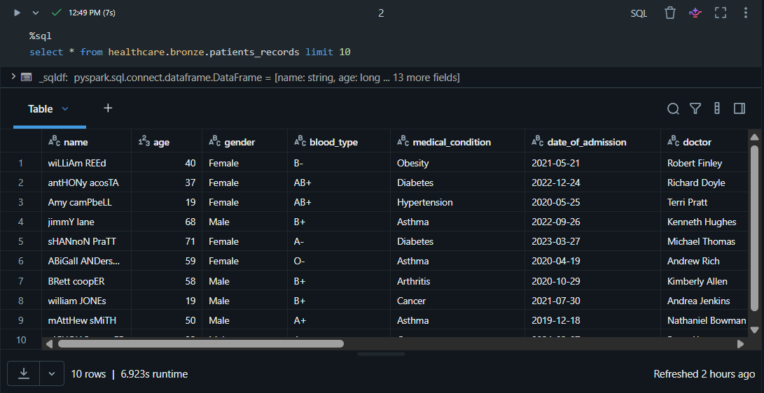
Description:
The raw healthcare dataset has been successfully ingested into the Bronze layer using Delta Lake without applying any transformations. This layer preserves the original data for traceability and future reprocessing.

Screenshot 3: Pipeline Folder Structure
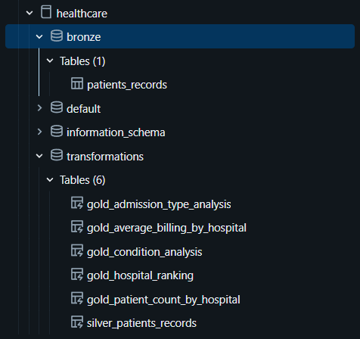
Description:
The Databricks Lakeflow Pipeline is organized into separate Silver and Gold transformation modules, ensuring a modular and maintainable pipeline structure.
Screenshot 4: Silver Transformation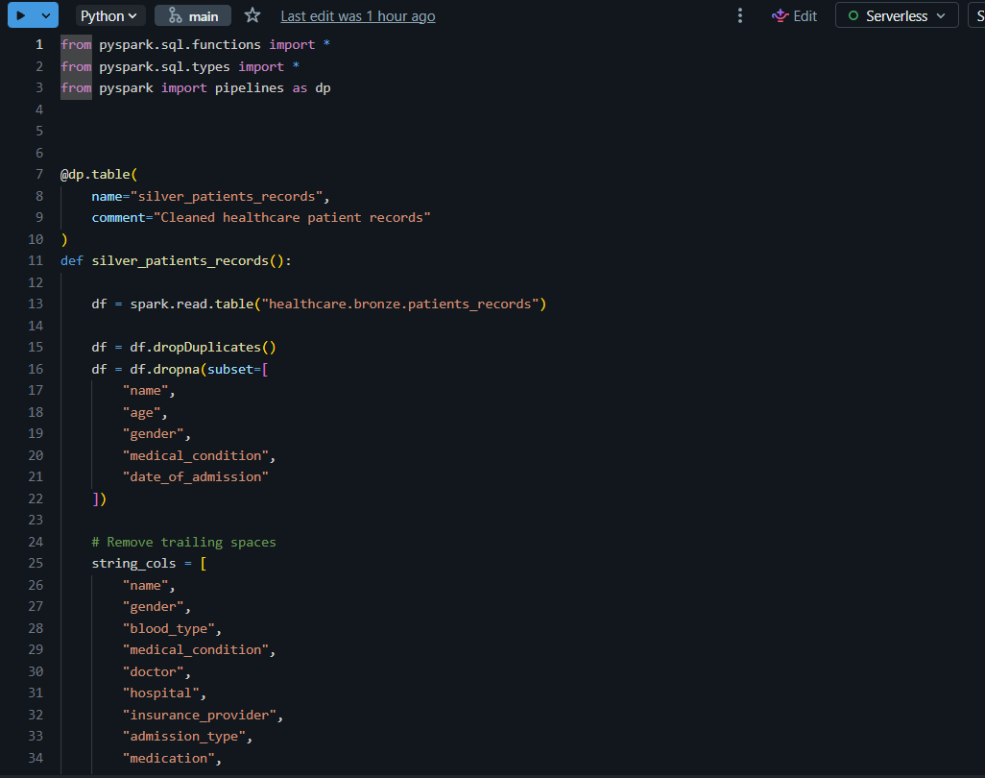Description:
The Silver layer performs data cleansing, duplicate removal, null handling, data type conversion, and standardization to prepare clean and reliable datasets for downstream analytics.

Screenshot 5: Pipeline Dependency Graph
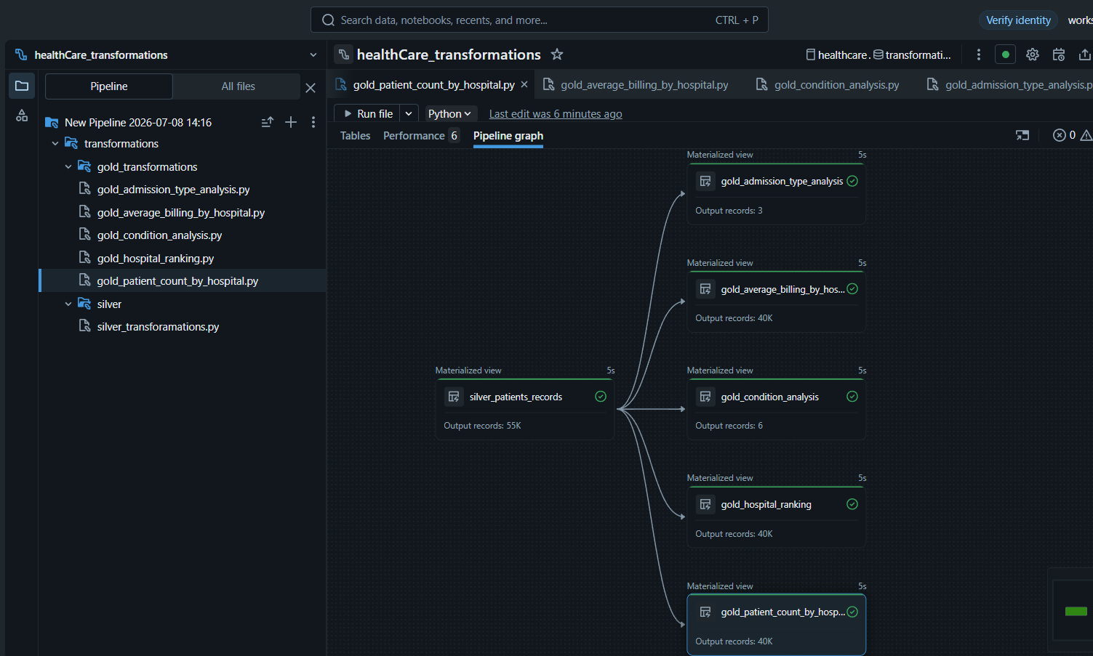
Description:
The pipeline graph illustrates the dependency between the Silver transformation and multiple Gold materialized views, representing the Medallion Architecture workflow.

Screenshot 7: Successful Pipeline Job Execution
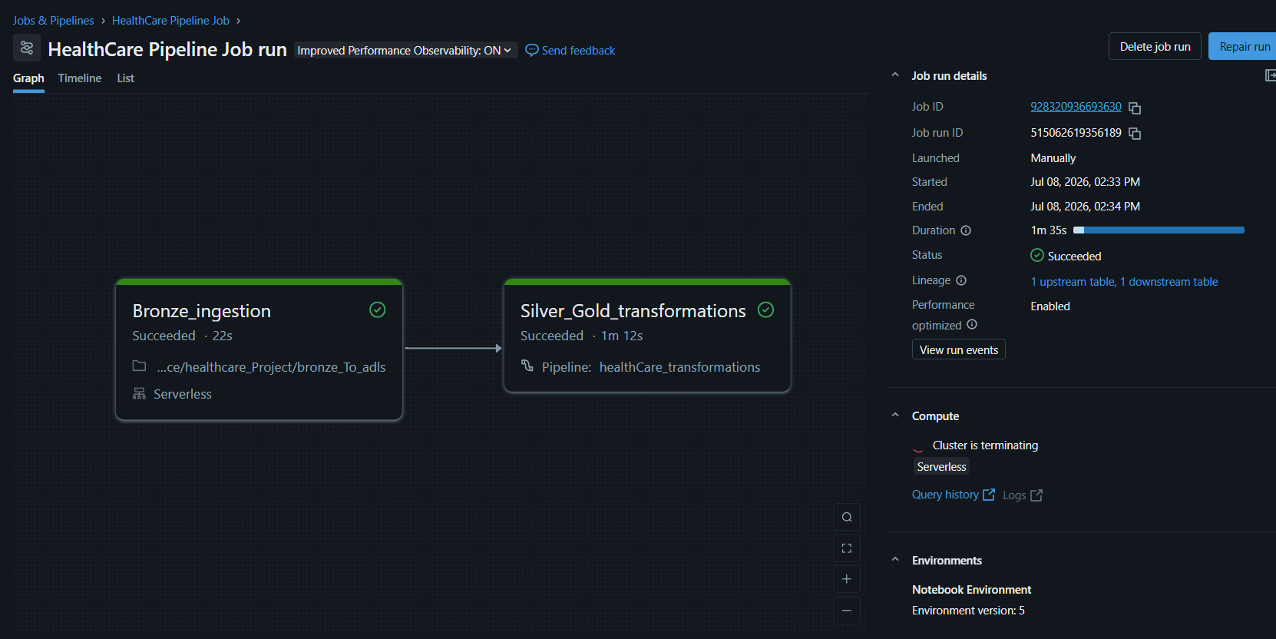
Description: The Healthcare Data Pipeline executed successfully, completing Bronze ingestion followed by Silver and Gold transformations through an automated Lakeflow Pipeline.

Screenshot 8: Gold Layer Output Tables
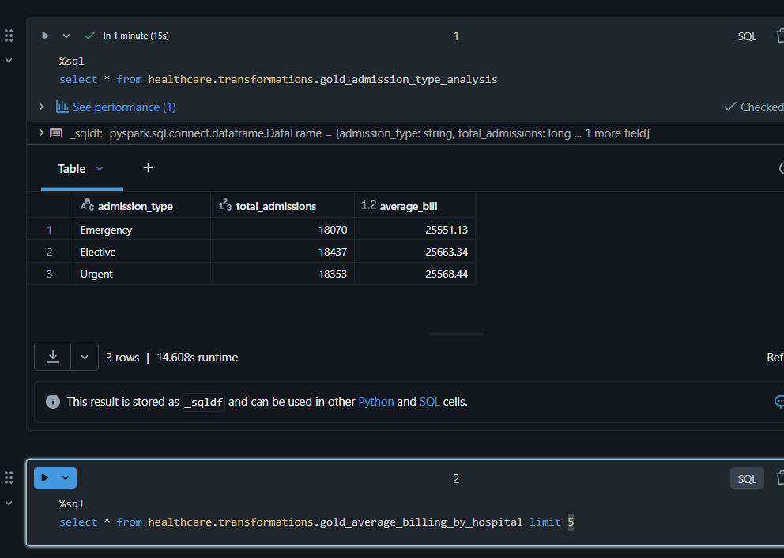
Description:
The Gold layer contains multiple business-oriented analytical tables, including patient count by hospital, hospital ranking, admission type analysis, medical condition analysis, and average billing by hospital.

Screenshot 9: GitHub Repository Structure
